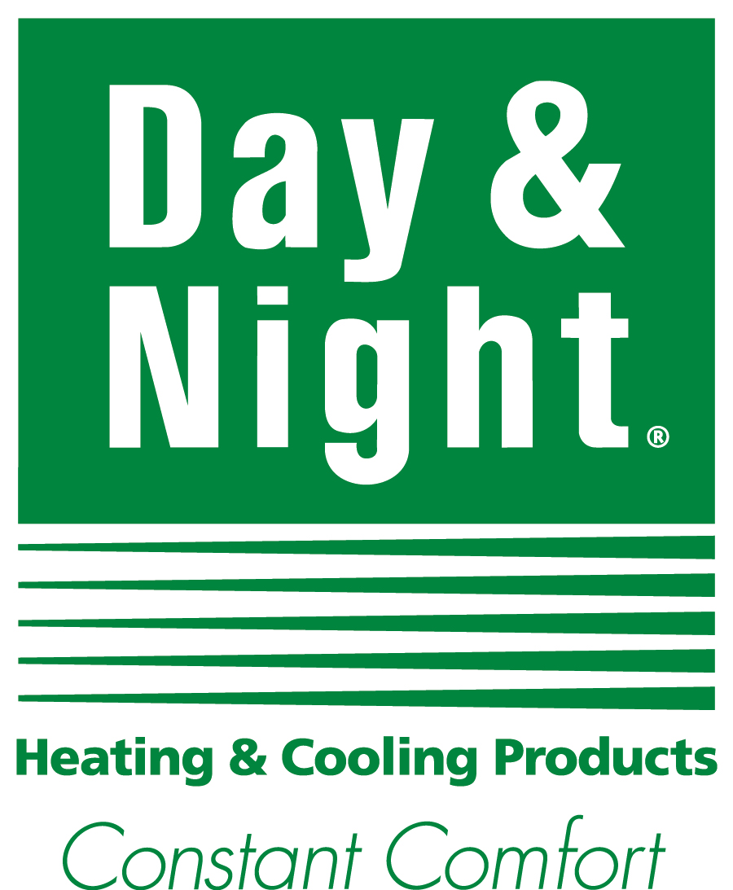

**RADIO SCRIPT**

**JOB NUMBER: 16-ICP-0033**

**DATE: 7/6/16**

**Heating Season Radio -- :23 Radio Script / :07 Dealer Tag**

Day & Night Product Excellence:

V/O:

Winter calls for consistent comfort, and that’s exactly what Day & Night heating systems deliver. You get round-the-clock comfort that’s consistently reliable whether it’s midnight or noon. Plus you can add the Observer communicating control with Wi-Fi capability that lets you remotely adjust your home comfort settings. Choose [Dealer name], your local Day & Night dealer, for the finest in 24-hour comfort. With Day & Night, you’ll stay cozy around the clock.

Call (555) 123-4567 or find us online at ABCHVAC.com. Day & Night. Constant Comfort.

Day & Night Dealer Quality:

V/O:

[Dealer name] understands that winter calls for constant comfort. Our goal is to keep you consistently cozy, and a fall tune-up can often prevent an emergency call in the middle of winter. You deserve to stay toasty, whatever the hour. Make Day & Night the name to remember when you need round-the-clock comfort. We’re the experts in 24-hour comfort. Day & Night.

Call (555) 123-4567 or find us online at ABCHVAC.com. Day & Night. Constant Comfort.

Day & Night Service:

V/O:

Why should you be occasionally cozy when you could be *constantly* comfortable? [Dealer name] can perform a timely fall tune-up to help you get 24-hour comfort, and it could even help lower your winter heating bills. Call us today to get the continuous comfort you deserve. Day & Night heating products plus reliable service from your local dealer. We specialize in round-the-clock comfort.

Call (555) 123-4567 or find us online at ABCHVAC.com. Day & Night. Constant Comfort.